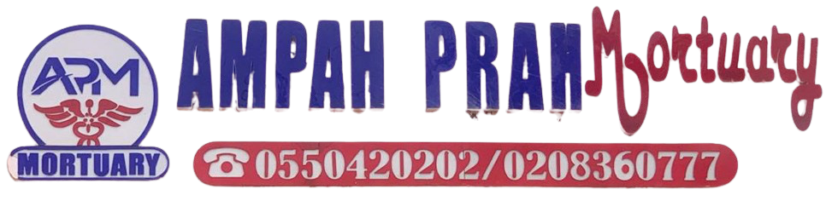
WASTE SEGREGATION PROTOCOL

Waste segregation color-coding helps to safely and effectively manage different types of waste.

Common colour codes include yellow for infectious waste, red for anatomical waste (like body parts), and black for general or non-hazardous waste.

Other colours like blue and white may also be used for specific waste types, such as non-hazardous or recyclable materials.

- Yellow:

Used for infectious waste, including items contaminated with bodily fluids, used syringes, and other potentially hazardous materials.

- Red:

Used for anatomical waste, such as tissues, organs, and body parts, especially after surgical procedures.

- Black:

Used for general waste, including paper, packaging, and other non-hazardous materials.

